

**Theory Assignment Report**

|  |  |  |  |  |  |  |
| --- | --- | --- | --- | --- | --- | --- |
| **Only for course Teacher** | | | | | | |
|  | | **Needs Improvement** | **Developing** | **Sufficient** | **Above Average** | **Total Mark** |
| **Allocate mark & Percentage** | | **25%** | **50%** | **75%** | **100%** | **5** |
| **Clarity** | **1** |  |  |  |  |  |
| **Content Quality** | **2** |  |  |  |  |  |
| **Spelling & Grammar** | **1** |  |  |  |  |  |
| **Organization and Formatting** | **1** |  |  |  |  |  |
| **Total obtained mark** | | | | | |  |
| **Comments** |  | | | | | |

**Semester: Spring 25**

**Student Name:** Nur Ahmed

**Student ID:** 222-35-1111

**Batch:** 38th  **Section:** A

**Course Code:** SE442

**Course Name:** Management Information System

**Course Teacher Name:** Dr. Imran Mahmud

**Designation:** Professor & Head

**Submission Date:** 18/04/2025

**Contents**

**Police Department Data Analysis** 3

**Frequency Tables (3)** 3

**Cross Tabs (2)** 4

# **Police Department Data Analysis**

## **Frequency Tables (3)**

|  |  |  |  |  |  |
| --- | --- | --- | --- | --- | --- |
| **Rank** | | | | | |
|  | | Frequency | Percent | Valid Percent | Cumulative Percent |
| Valid | Captain | 38 | 19.0 | 19.0 | 19.0 |
| Chief | 35 | 17.5 | 17.5 | 36.5 |
| Constable | 25 | 12.5 | 12.5 | 49.0 |
| Inspector | 42 | 21.0 | 21.0 | 70.0 |
| Lieutenant | 30 | 15.0 | 15.0 | 85.0 |
| Sergeant | 30 | 15.0 | 15.0 | 100.0 |
| Total | 200 | 100.0 | 100.0 |  |

|  |  |  |  |  |  |
| --- | --- | --- | --- | --- | --- |
| **Department** | | | | | |
|  | | Frequency | Percent | Valid Percent | Cumulative Percent |
| Valid | Cyber Crime | 34 | 17.0 | 17.0 | 17.0 |
| Homicide | 32 | 16.0 | 16.0 | 33.0 |
| Narcotics | 42 | 21.0 | 21.0 | 54.0 |
| Patrol | 29 | 14.5 | 14.5 | 68.5 |
| Special Branch | 28 | 14.0 | 14.0 | 82.5 |
| Traffic | 35 | 17.5 | 17.5 | 100.0 |
| Total | 200 | 100.0 | 100.0 |  |

|  |  |  |  |  |  |
| --- | --- | --- | --- | --- | --- |
| **Status** | | | | | |
|  | | Frequency | Percent | Valid Percent | Cumulative Percent |
| Valid | Active | 65 | 32.5 | 32.5 | 32.5 |
| On Leave | 79 | 39.5 | 39.5 | 72.0 |
| Retired | 56 | 28.0 | 28.0 | 100.0 |
| Total | 200 | 100.0 | 100.0 |  |

## **Cross Tabs (2)**

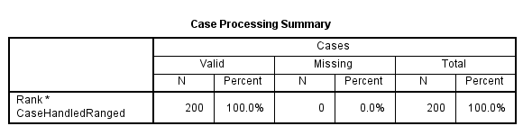

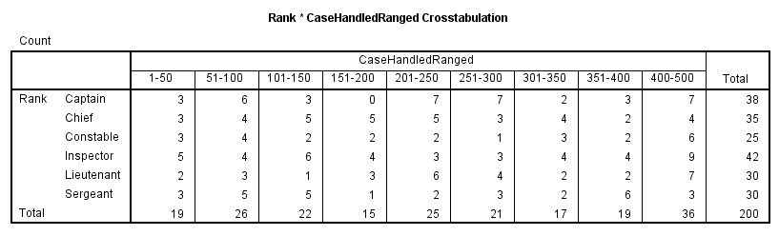

|  |  |  |  |  |  |  |
| --- | --- | --- | --- | --- | --- | --- |
| **Case Processing Summary** | | | | | | |
|  | Cases | | | | | |
| Valid | | Missing | | Total | |
| N | Percent | N | Percent | N | Percent |
| Rank * BigRangedCaseHandled | 200 | 100.0% | 0 | 0.0% | 200 | 100.0% |

|  |  |  |  |  |  |  |
| --- | --- | --- | --- | --- | --- | --- |
| **Rank * BigRangedCaseHandled Crosstabulation** | | | | | | |
| Count | | | | | | |
|  | | BigRangedCaseHandled | | | | Total |
| 1-151 | 151-300 | 301-450 | 451-551 |
| Rank | Captain | 12 | 14 | 10 | 2 | 38 |
| Chief | 12 | 13 | 8 | 2 | 35 |
| Constable | 9 | 5 | 10 | 1 | 25 |
| Inspector | 15 | 10 | 12 | 5 | 42 |
| Lieutenant | 6 | 13 | 7 | 4 | 30 |
| Sergeant | 13 | 6 | 11 | 0 | 30 |
| Total | | 67 | 61 | 58 | 14 | 200 |